Code 1
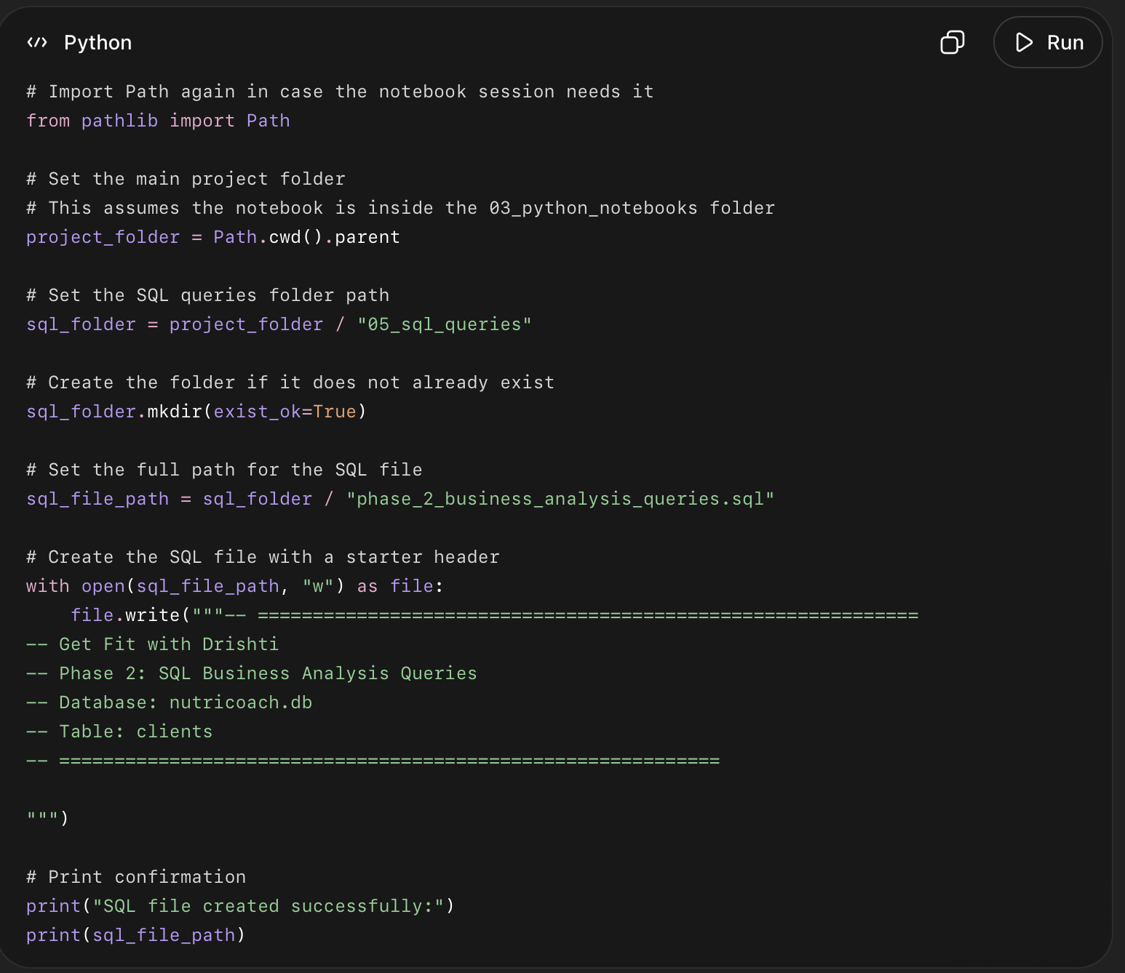

What this code did
- Found your main project folder.
- Opened the 05_sql_queries folder.
- Created the folder if it was missing.
- Created a new SQL file named phase_2_business_analysis_queries.sql.
- Added a clean header inside the file.
- This file will store all 13 SQL business analysis queries later.
Code 2
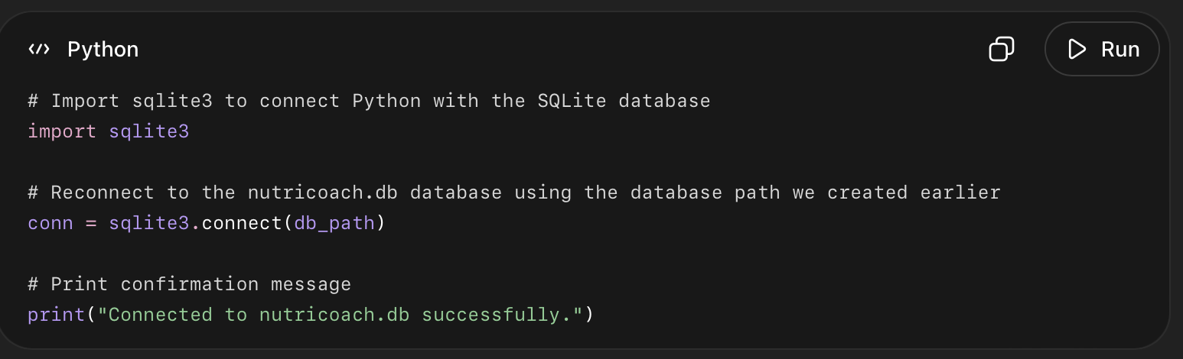

What this code did
- Imported sqlite3, which lets Python work with SQLite databases.
- Reconnected your notebook to the existing nutricoach.db file.
- Stored the database connection in conn.
- Now Python can run SQL queries on your clients table again.

Query 1 — Goal Type Breakdown
This will show:
- how many clients joined for each goal
- what percentage of total clients each goal represents
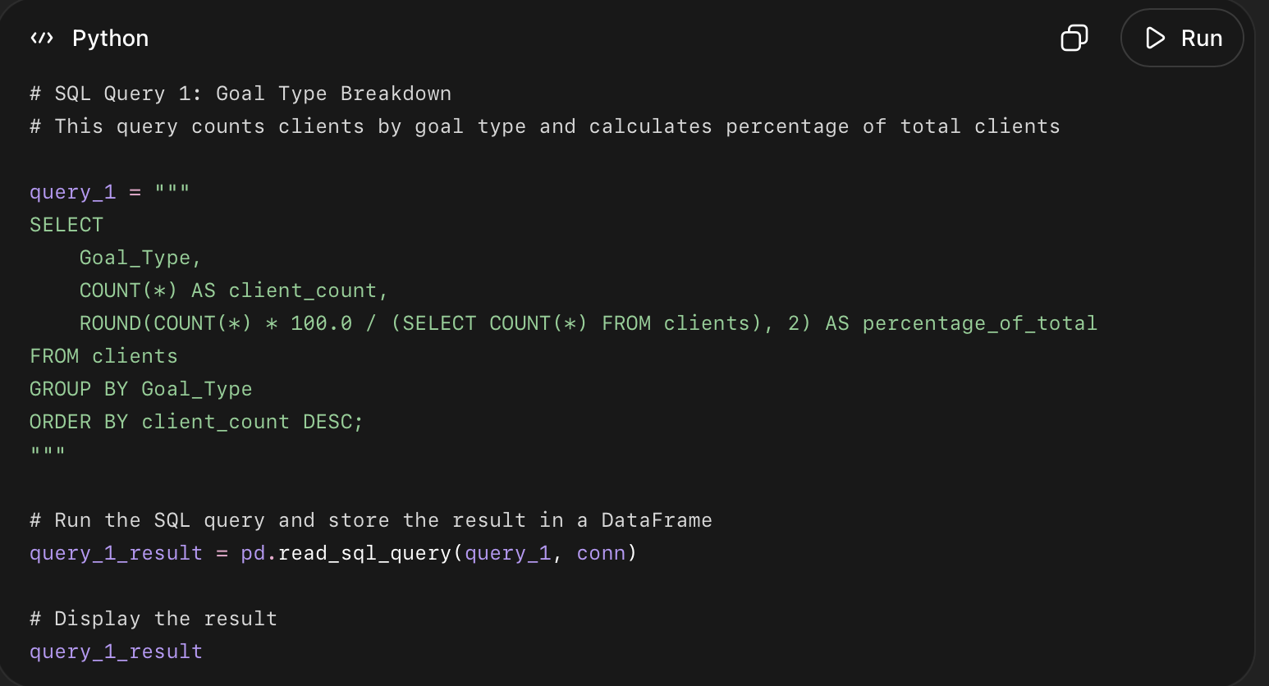

What this code did
- Looked at the Goal_Type column.
- Grouped clients by their goal: weight loss, body transformation, or weight gain.
- Counted how many clients are in each goal category.
- Calculated what percentage of all 3,000 clients each goal represents.
- Sorted the result from the biggest client group to the smallest.

What this query answers
This query answers: What are the main goals clients come to Get Fit with Drishti for?

Query saving:
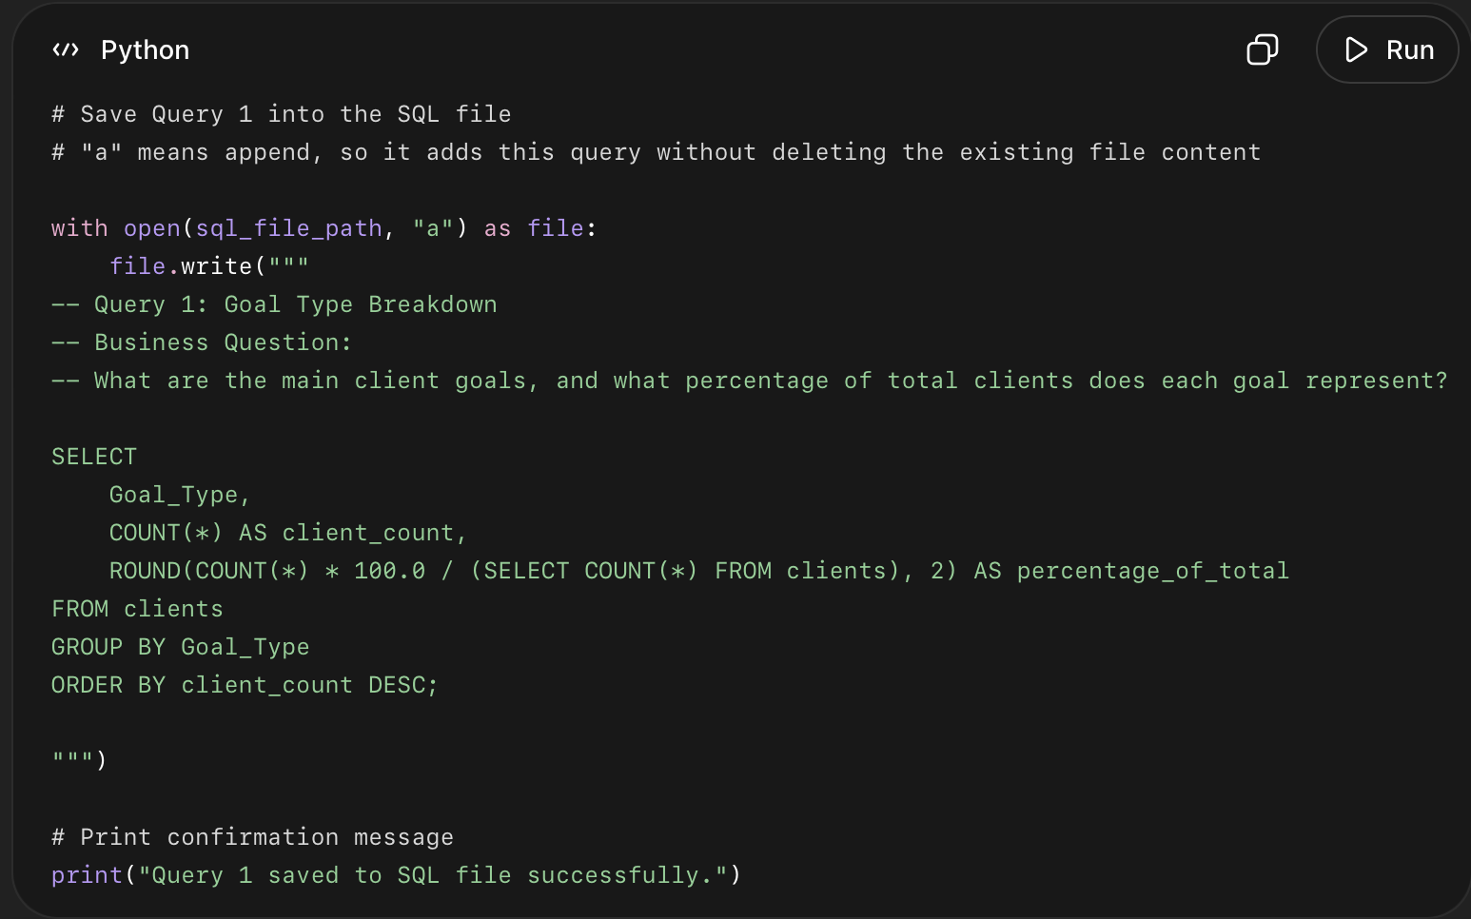

What this code did
- Opened your file: phase_2_business_analysis_queries.sql.
- Used append mode "a" so it did not delete the file header.
- Added Query 1 to the SQL file.
- Added comments explaining the business question.
- Saved the query for your final portfolio files.

QUERY 2
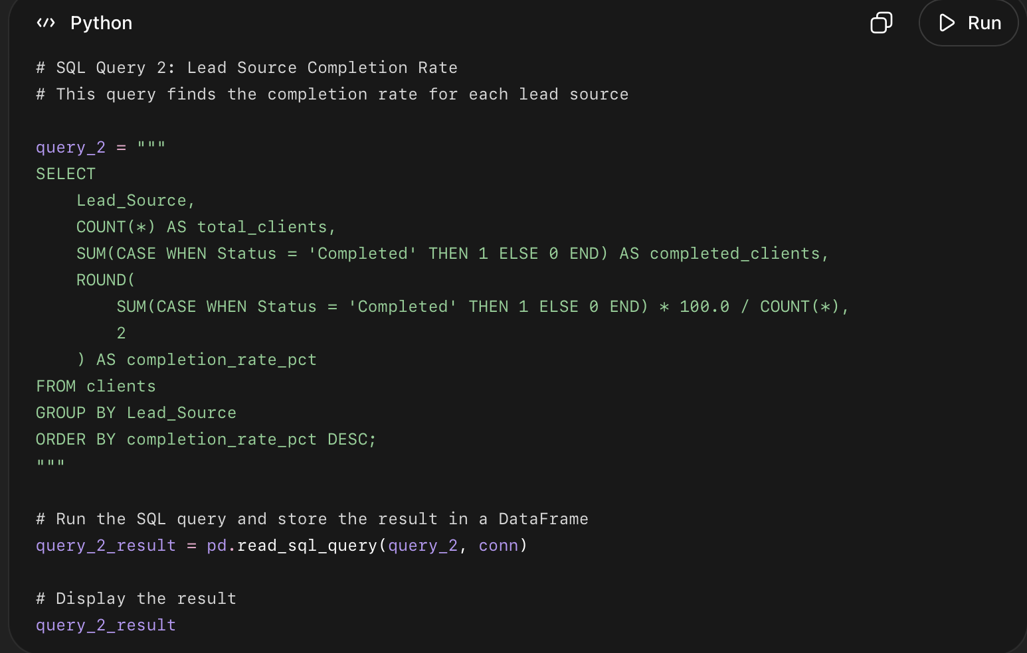

What this code did
- Grouped all clients by Lead_Source.
- Counted total clients from each source.
- Counted how many clients from each source completed the program.
- Calculated the completion rate percentage for each source.
- Sorted the result so the best-performing lead source appears first.

What this query answers
This query answers: Which marketing channel brings clients who are most likely to complete the program?

Query 3
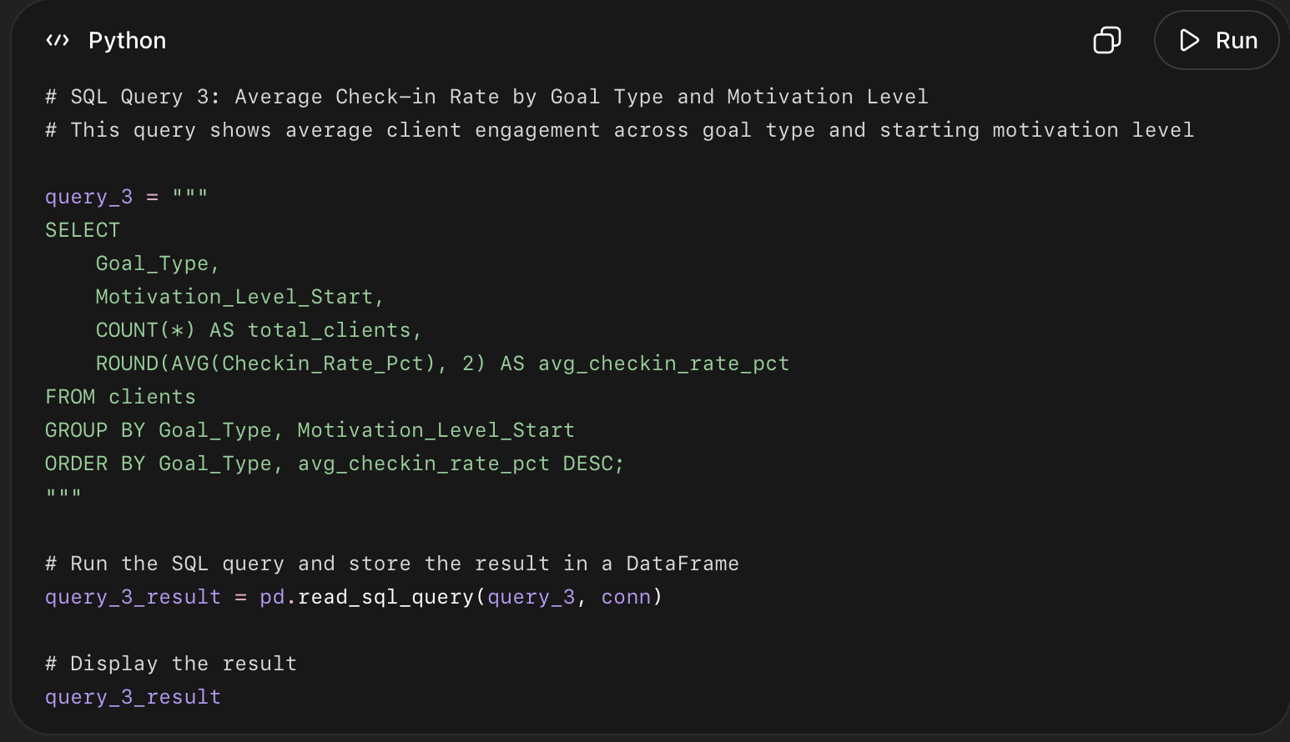
Average Check-in Rate by Goal Type and Motivation Level

What this code did
- Grouped clients by both Goal_Type and Motivation_Level_Start.
- Counted how many clients are in each group.
- Calculated the average check-in rate for each group.
- Sorted the results by goal type and highest average check-in rate.
- This helps us understand which client groups are more engaged during the program.

What this query answers
This query answers: Which goal and motivation groups have the highest or lowest check-in engagement?

Query 4:
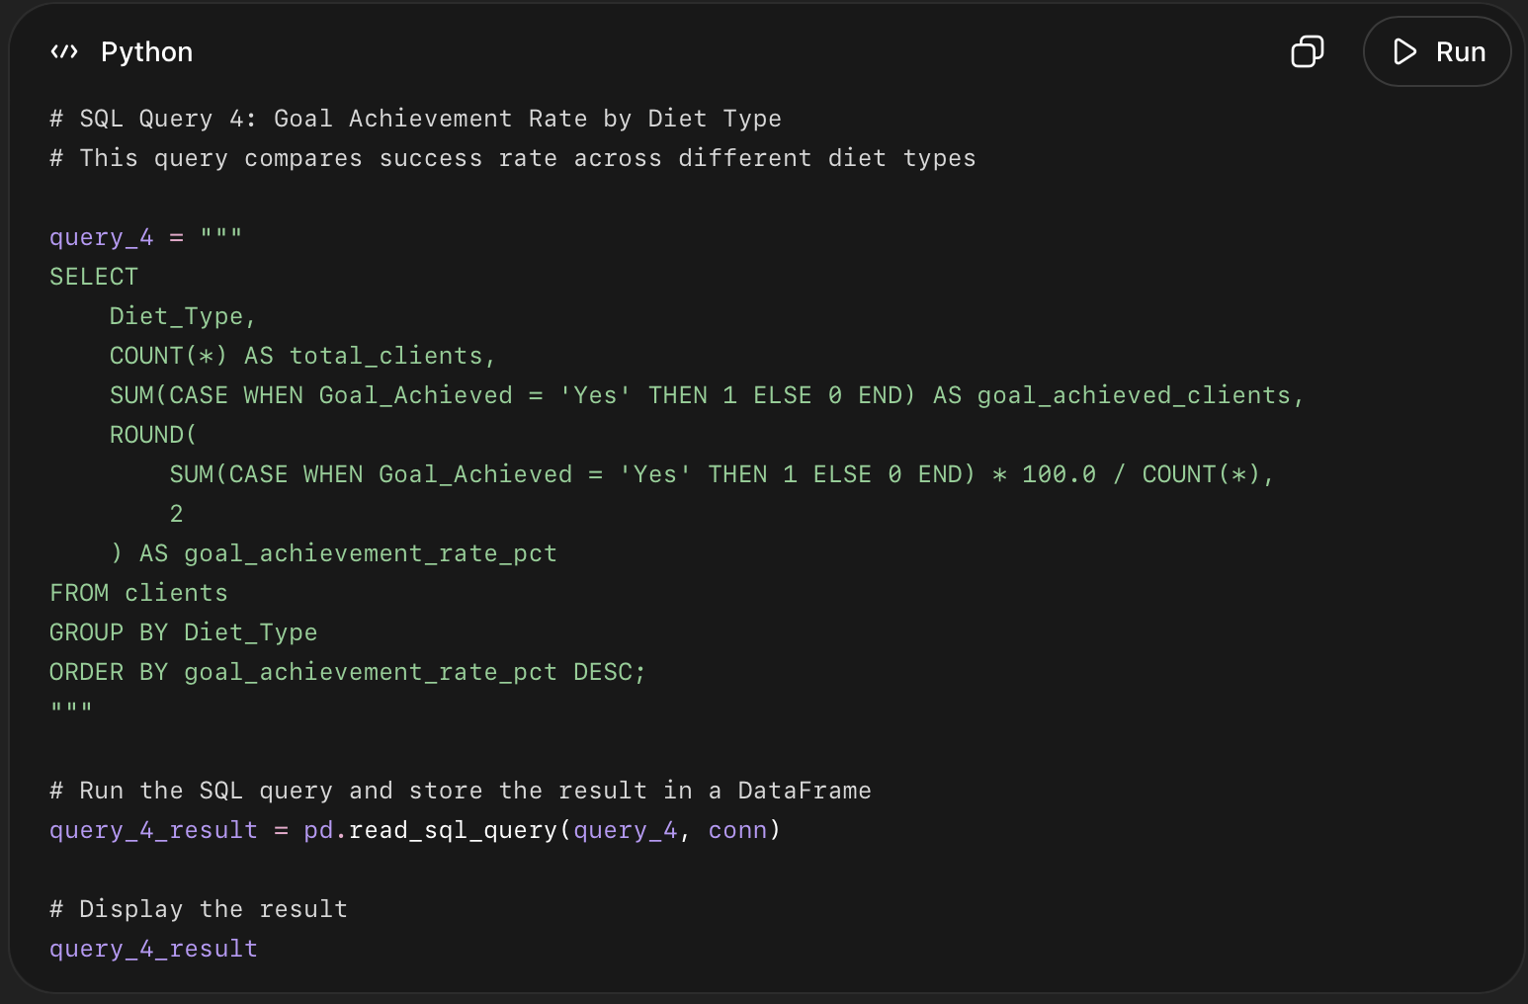
Goal Achievement Rate by Diet Type
What this code did
- Grouped clients by Diet_Type.
- Counted total clients in each diet category.
- Counted how many clients fully achieved their goal.
- Calculated the goal achievement rate for each diet type.
- Sorted the result from highest success rate to lowest.
- What this query answers
This query answers: Does diet type appear to affect client success?
Query 5
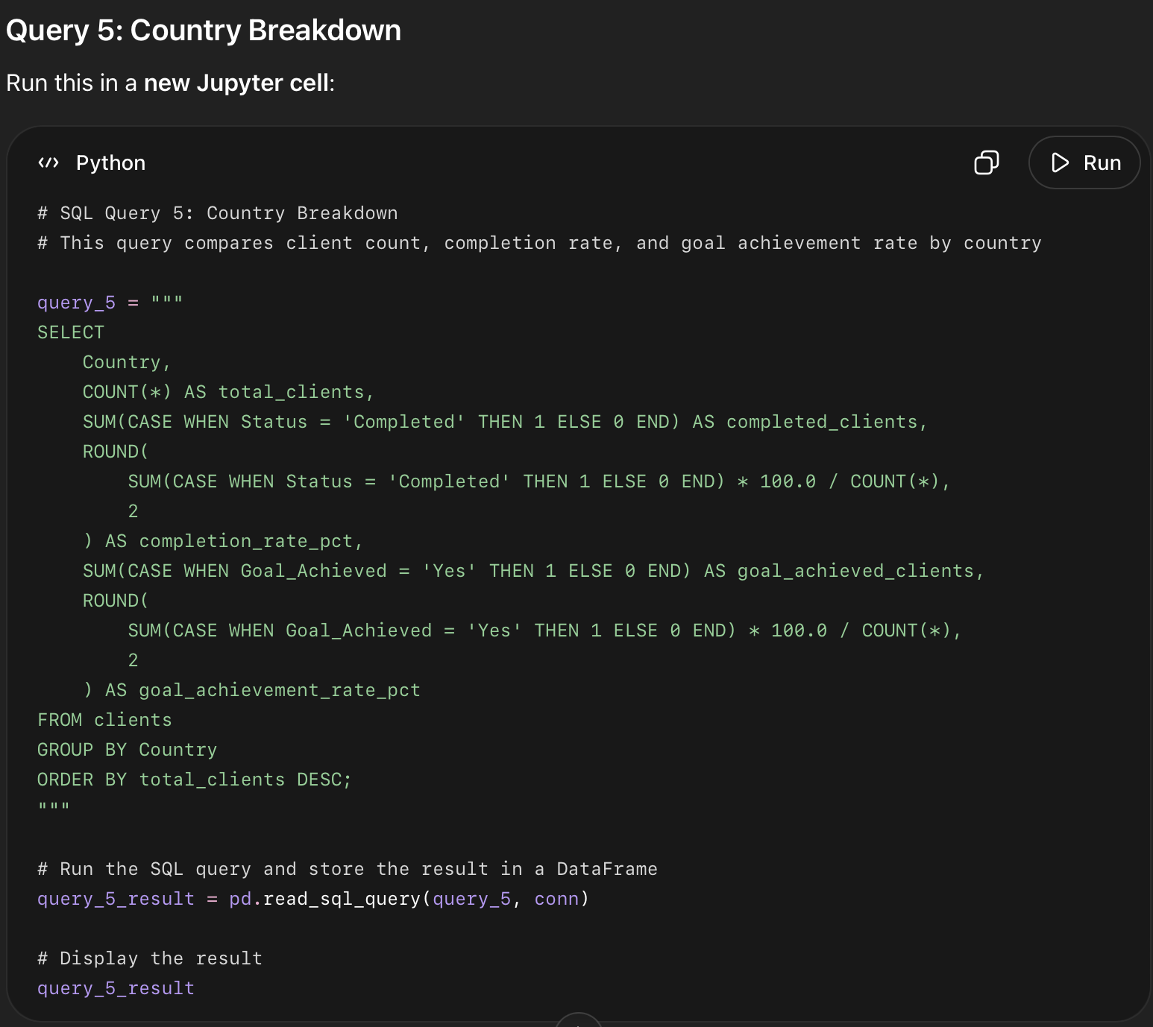

What this code did
- Grouped clients by Country.
- Counted total clients from each country.
- Counted how many clients completed the program in each country.
- Calculated completion rate for each country.
- Counted how many clients fully achieved their goal in each country.
- Calculated goal achievement rate for each country.
- Sorted countries by highest client count.

What this query answers
This query answers: Which countries bring the most clients, and how successful are clients from each country?

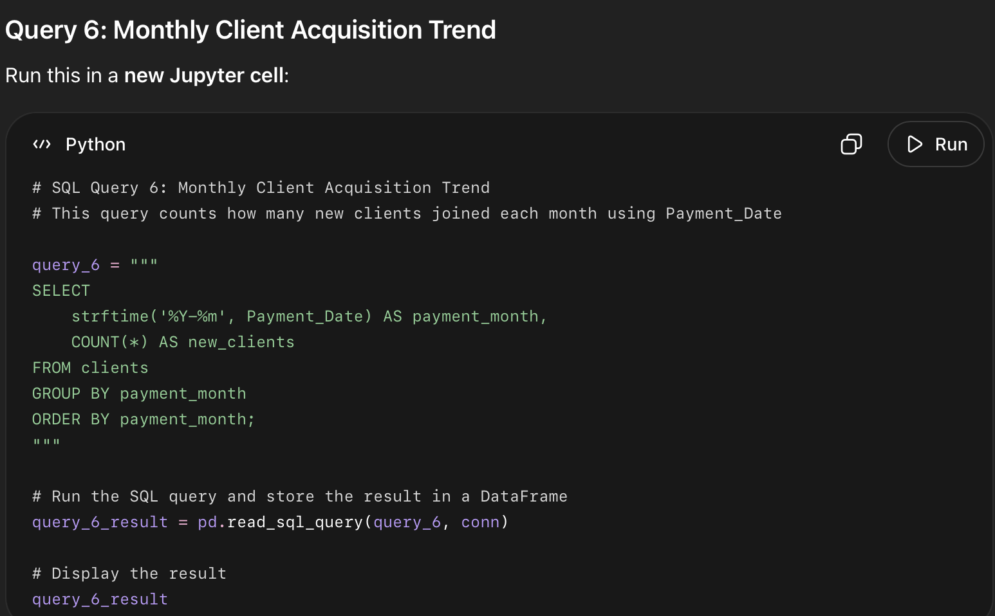

What this code did
- Used the Payment_Date column to identify when clients paid and joined.
- Converted each payment date into a monthly format: YYYY-MM.
- Counted how many clients joined in each month.
- Sorted the result from earliest month to latest month.
- This helps show business growth over time.

What this query answers
This query answers: How many new clients joined each month?

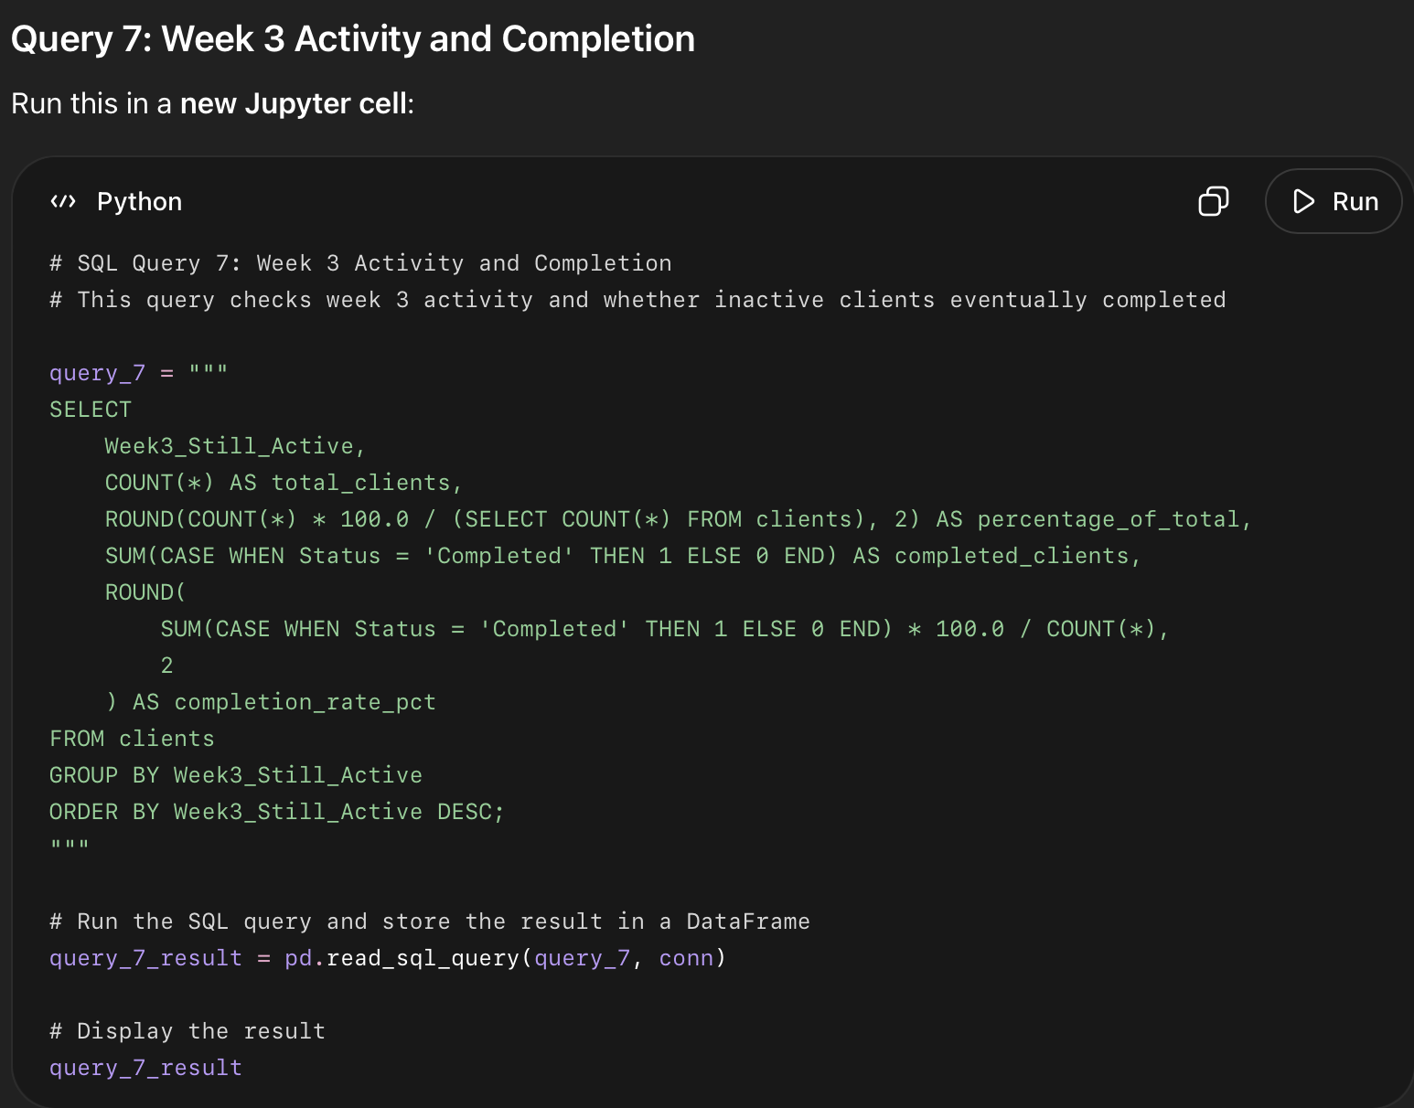

What this code did
- Grouped clients by whether they were still active at week 3.
- Counted how many clients were active vs not active at week 3.
- Calculated what percentage of all clients each group represented.
- Counted how many clients in each group eventually completed the program.
- Calculated the completion rate for both groups.

What this query answers
This query answers: Is week 3 activity a strong early warning signal for program completion?

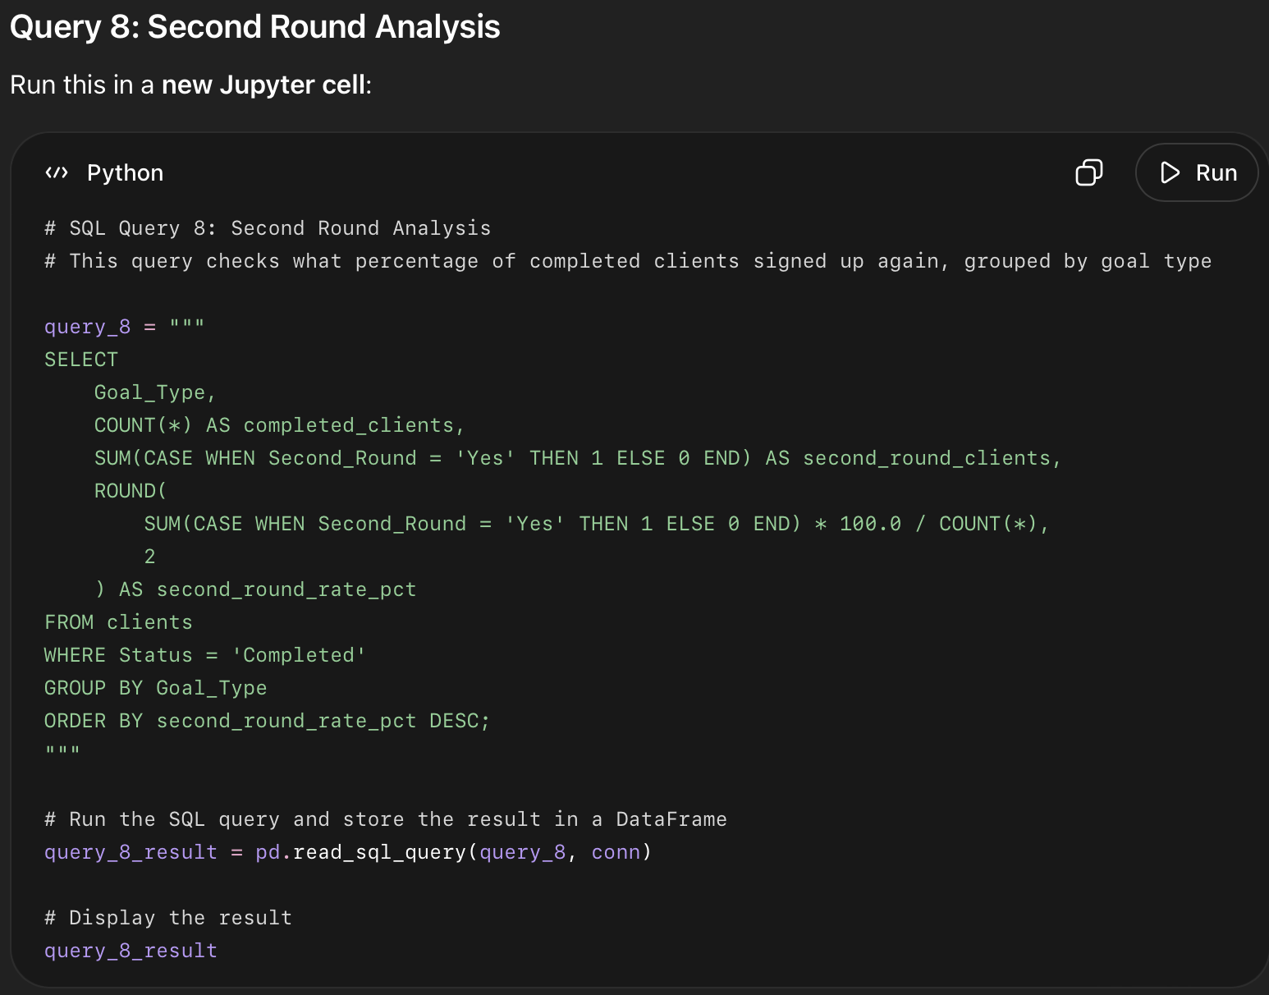

What this code did
- Filtered the data to include only clients whose Status is Completed.
- Grouped completed clients by Goal_Type.
- Counted how many completed clients were in each goal group.
- Counted how many completed clients signed up for a second round.
- Calculated the second-round signup rate for each goal type.
- Sorted the result from highest repeat rate to lowest.

What this query answers
This query answers: Which completed client goal group is most likely to sign up again?

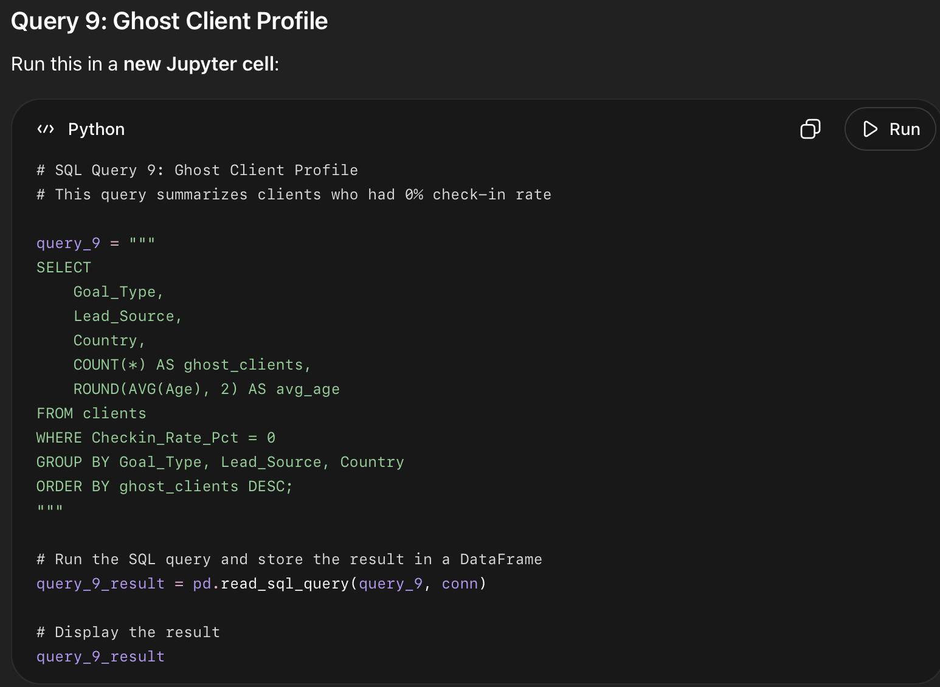

What this code did
- Filtered the dataset to only clients with Checkin_Rate_Pct = 0.
- These are ghost clients because they paid but never completed any check-ins.
- Grouped ghost clients by Goal_Type, Lead_Source, and Country.
- Counted how many ghost clients are in each profile group.
- Calculated the average age of ghost clients in each group.
- Sorted the result so the largest ghost-client groups appear first.

What this query answers
This query answers: Who are the clients most likely to disappear without checking in?

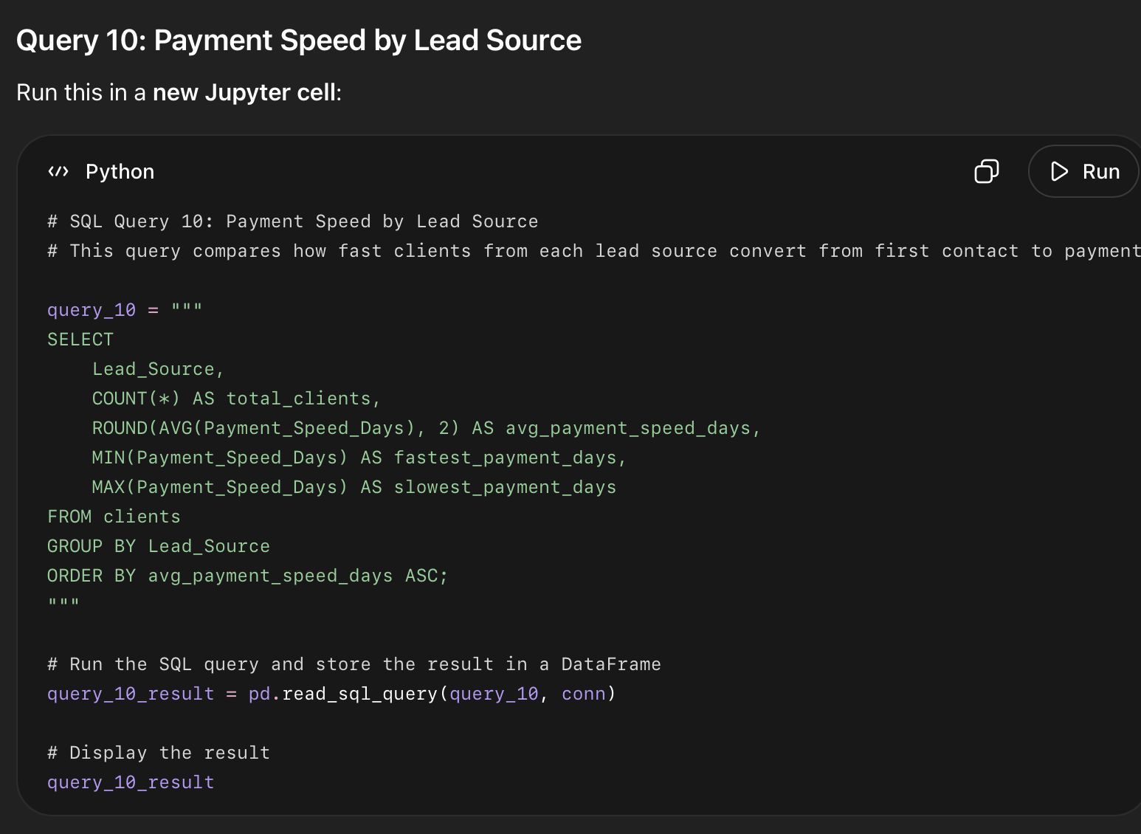

What this code did
- Grouped clients by Lead_Source.
- Counted how many clients came from each source.
- Calculated the average number of days from first contact to payment.
- Showed the fastest and slowest payment time for each lead source.
- Sorted the result so the fastest-converting channel appears first.

What this query answers
This query answers: Which lead source converts clients from first contact to payment the fastest?

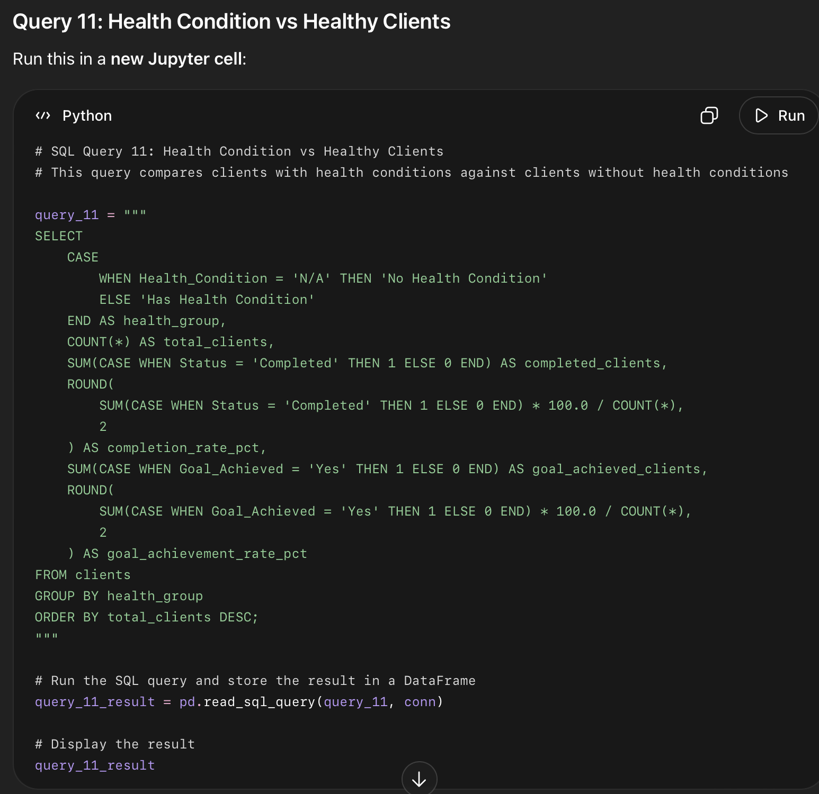

What this code did
- Created two groups:
  - clients with no health condition
  - clients with a health condition
- Counted total clients in each group.
- Counted how many clients completed the program.
- Calculated completion rate for each group.
- Counted how many clients fully achieved their goal.
- Calculated goal achievement rate for each group.

What this query answers
This query answers: Do clients with health conditions perform differently from clients without health conditions?

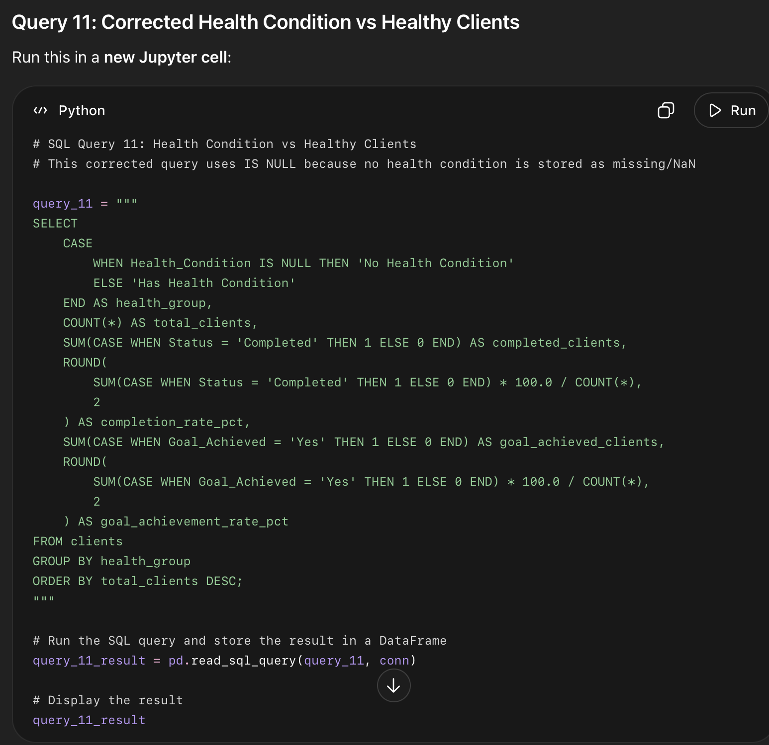

What this code did
- Corrected the health condition grouping.
- Treated missing Health_Condition values as No Health Condition.
- Treated all actual values like PCOS, Thyroid, Back Pain, Diabetes, and Other as Has Health Condition.
- Compared both groups by:
  - total clients
  - completed clients
  - completion rate
  - goal achieved clients
  - goal achievement rate

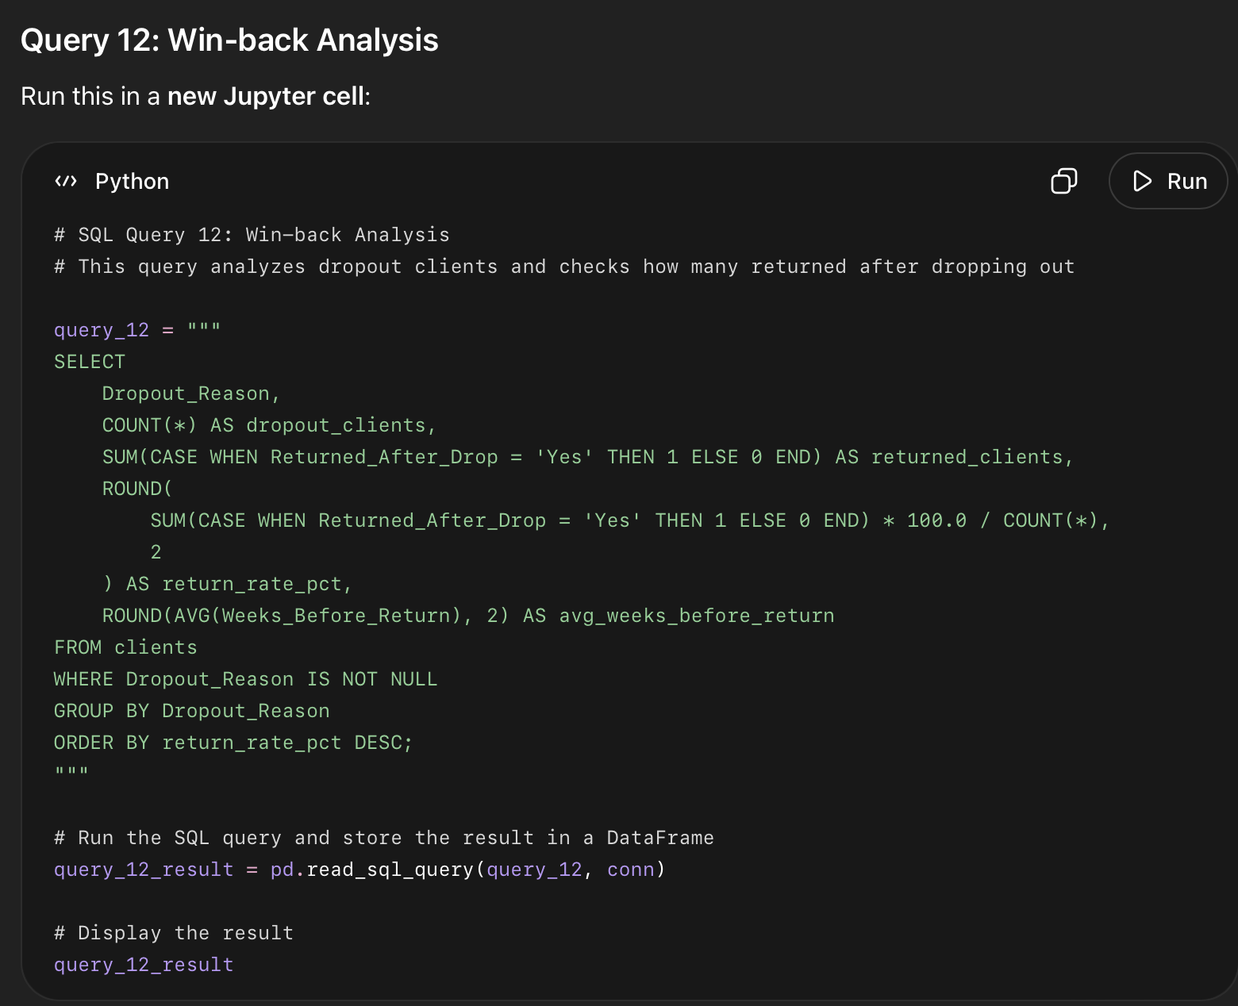

What this code did
- Filtered the data to only clients who had a dropout reason.
- Grouped dropout clients by Dropout_Reason.
- Counted how many clients dropped out for each reason.
- Counted how many of those clients returned after dropping out.
- Calculated the return/win-back rate for each dropout reason.
- Calculated the average number of weeks before clients returned.

What this query answers
This query answers: Which dropout reasons are most likely to turn into successful win-backs?
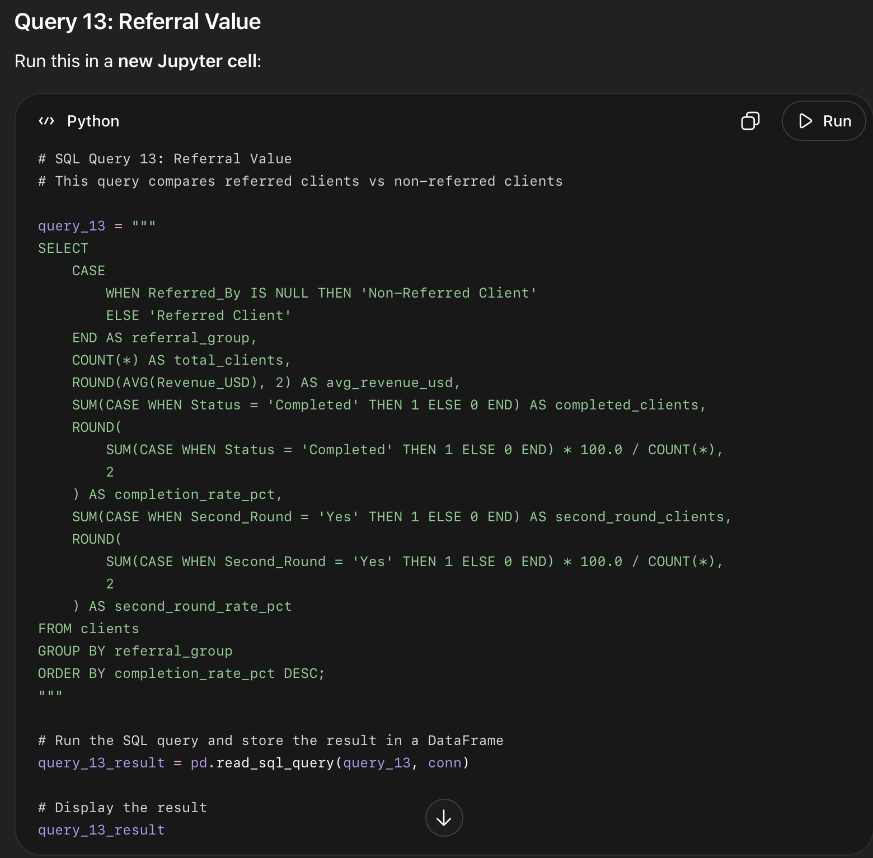

What this code did
- Split clients into two groups:
  - Referred Client
  - Non-Referred Client
- Counted how many clients are in each group.
- Calculated average revenue in USD for each group.
- Counted how many clients completed the program.
- Calculated completion rate for each group.
- Counted how many clients signed up for a second round.
- Calculated second-round rate for each group.

What this query answers
This query answers: Are referred clients more valuable than non-referred clients?

Query 13
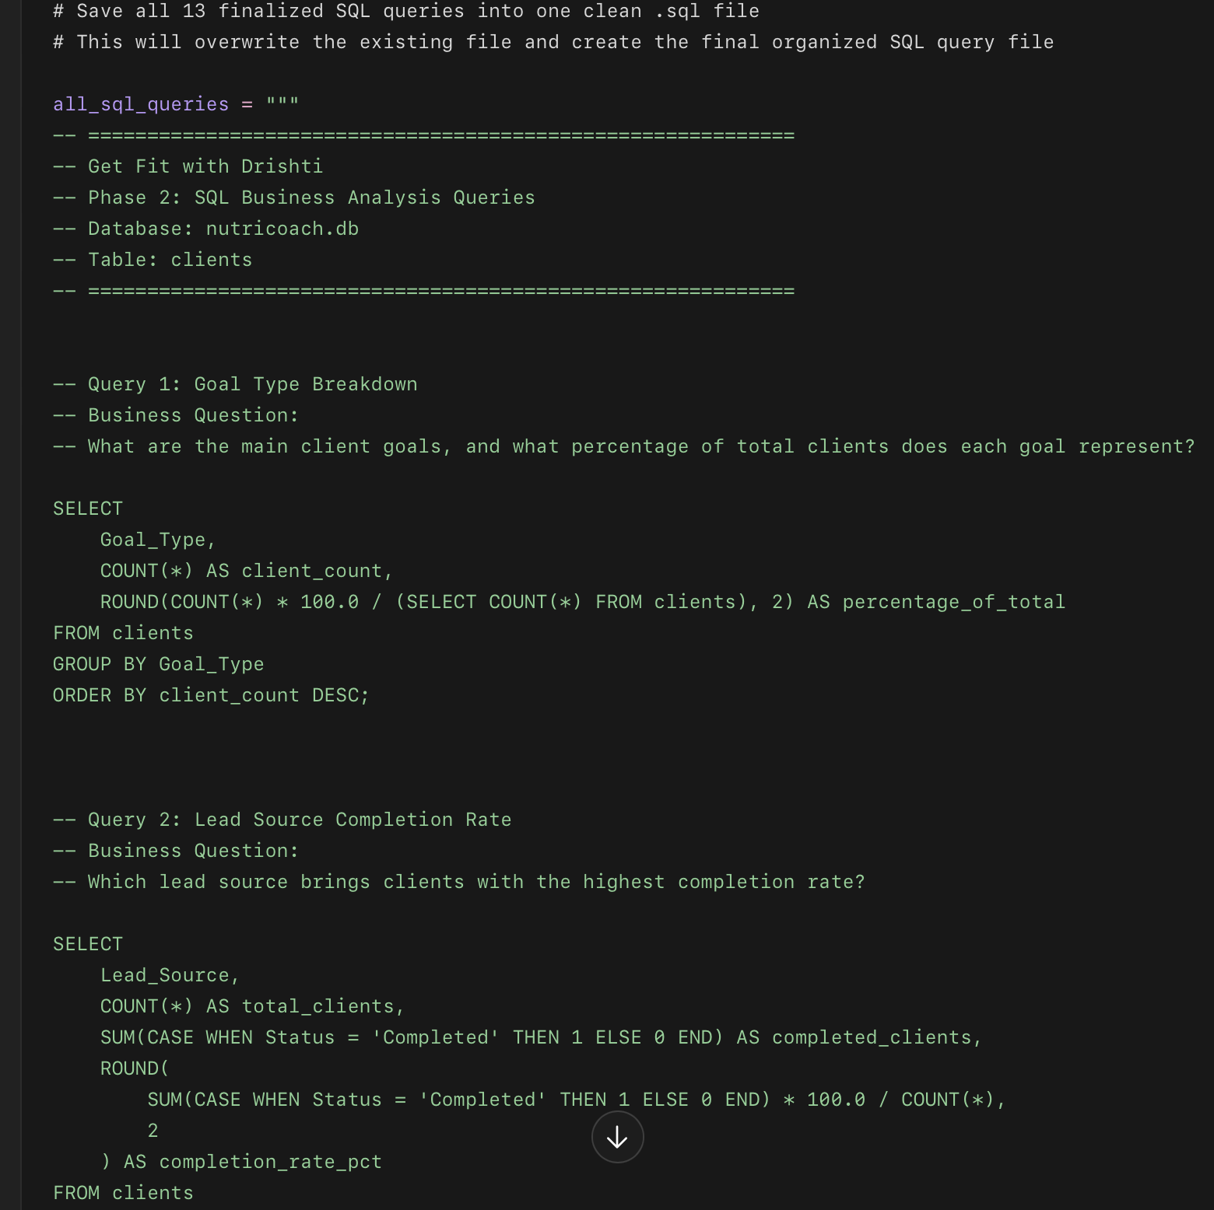
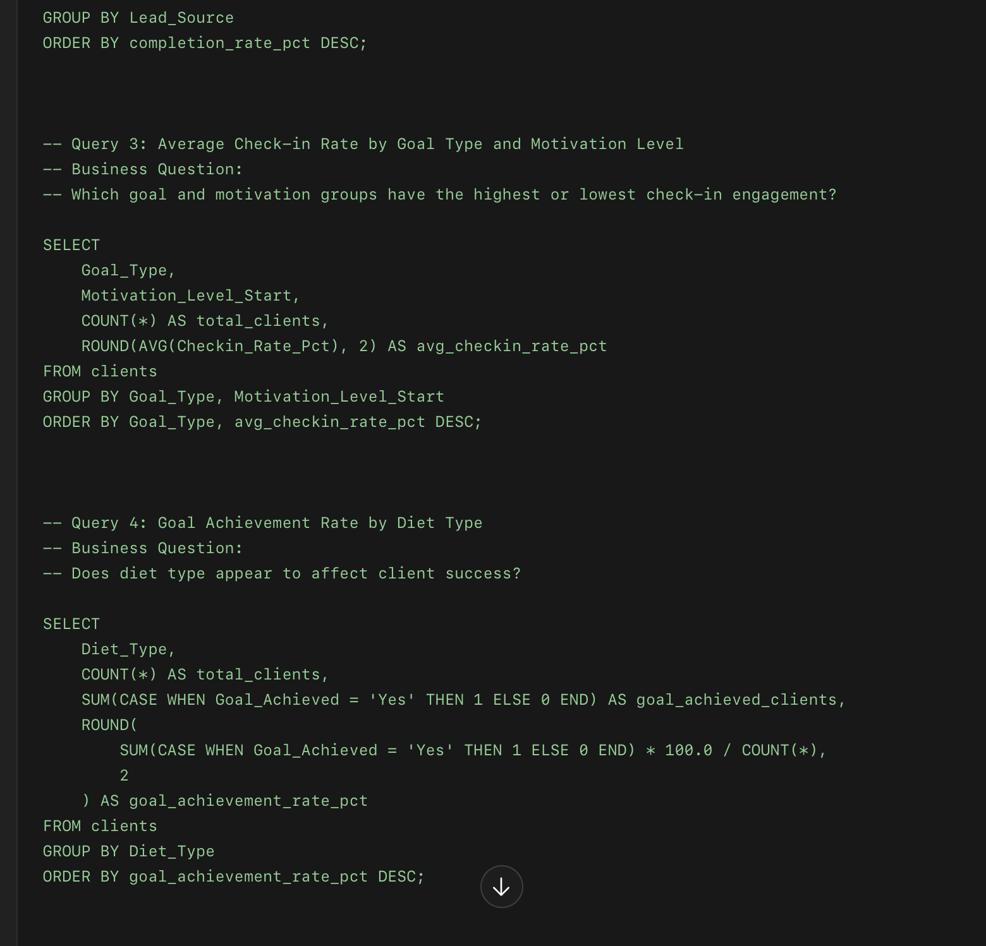
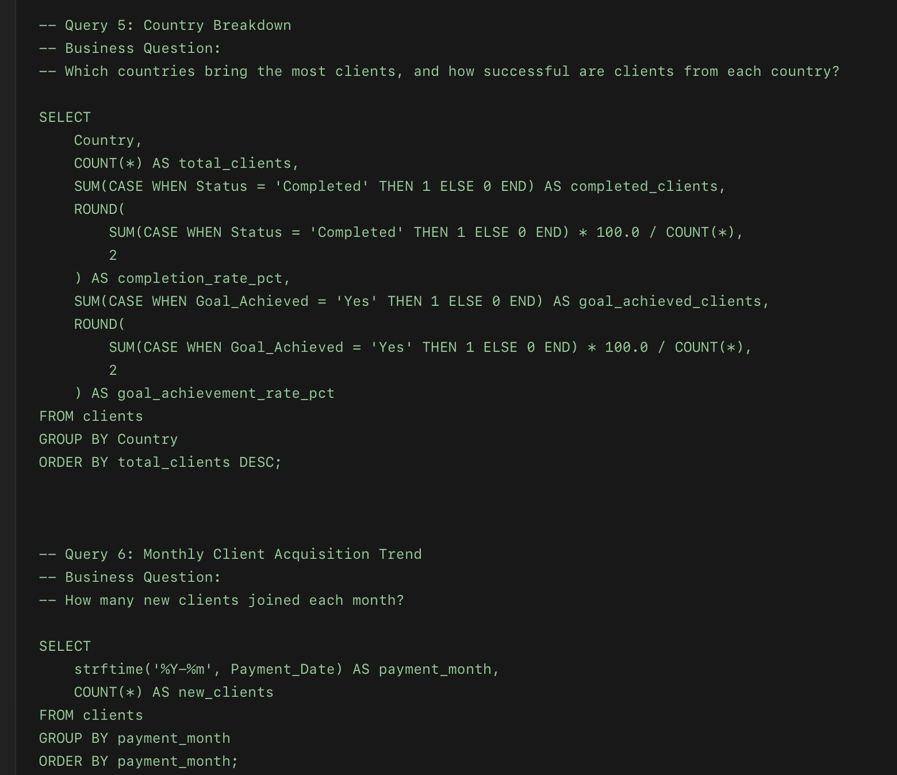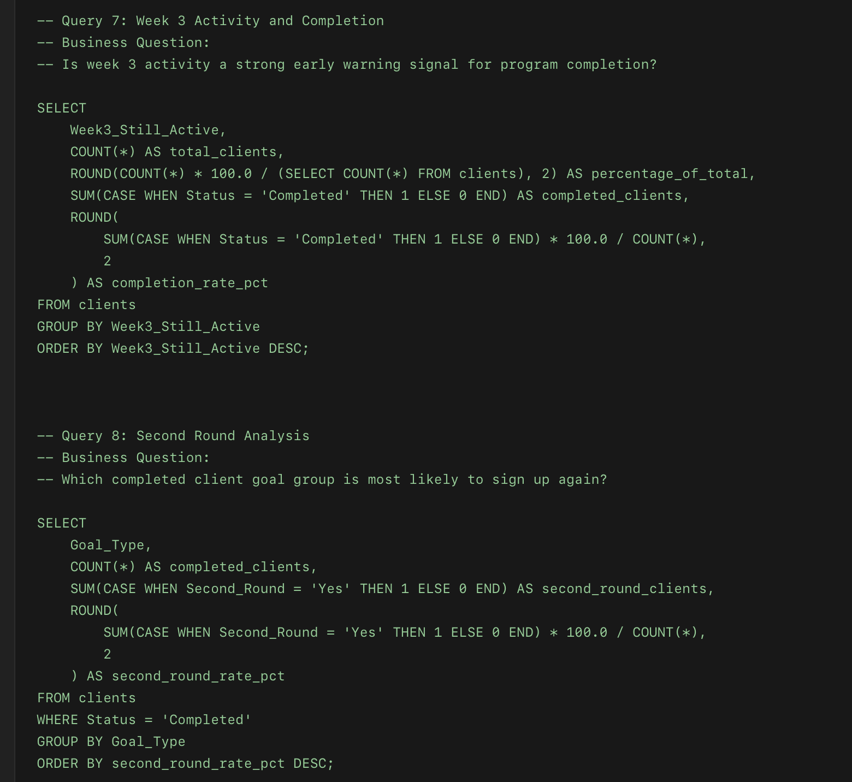
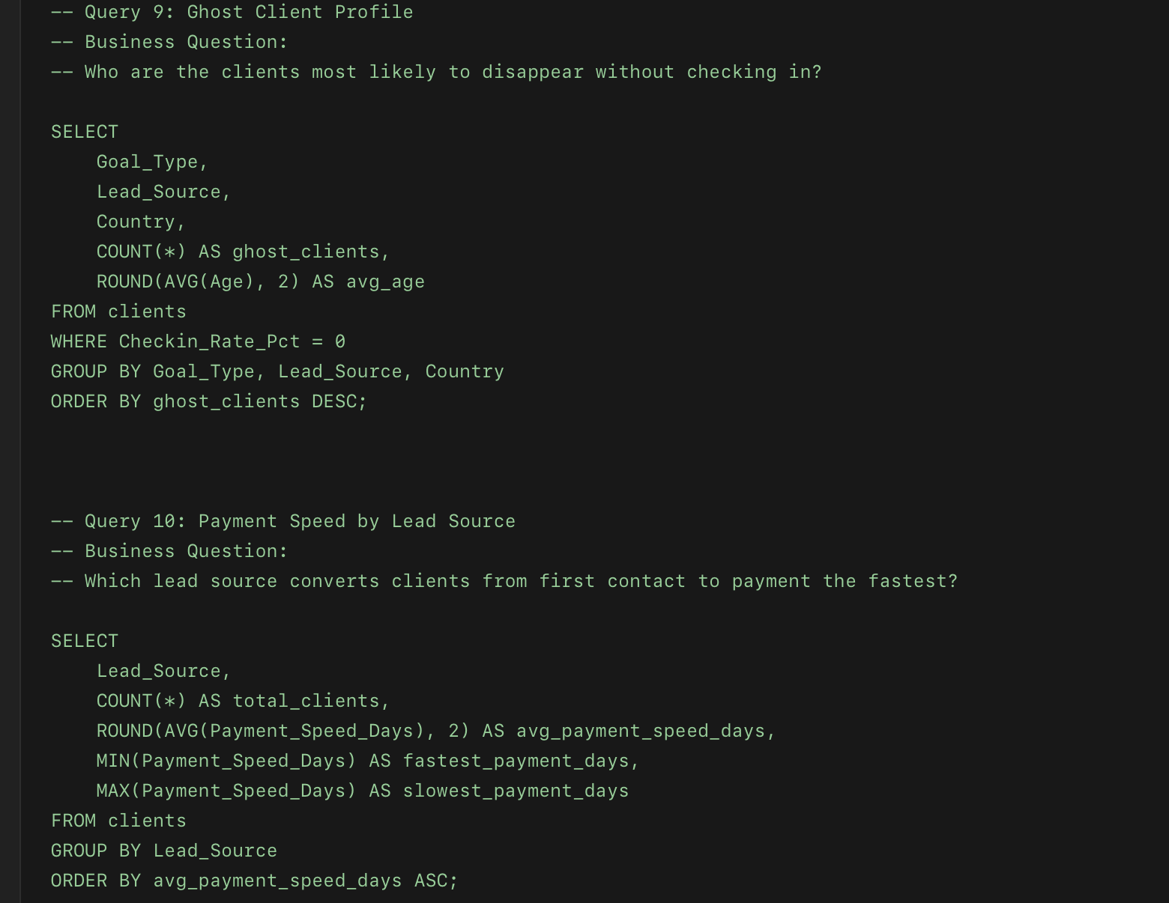
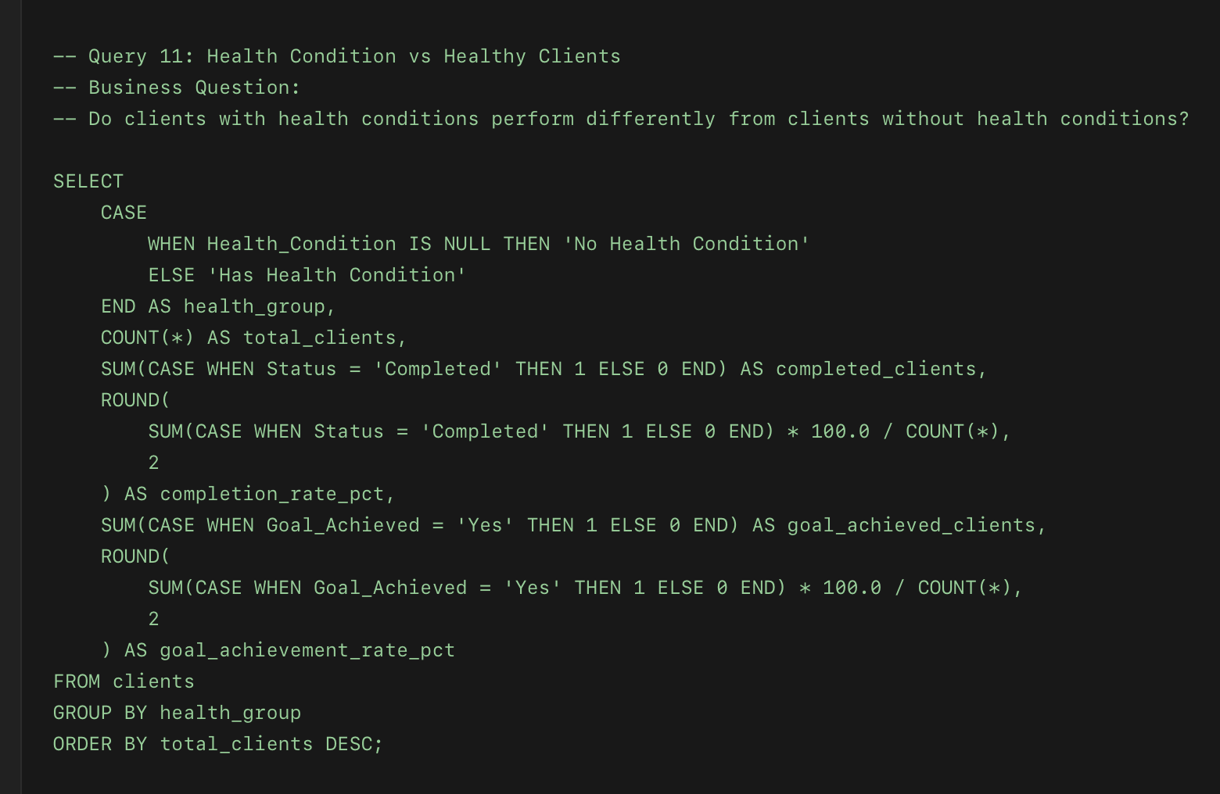
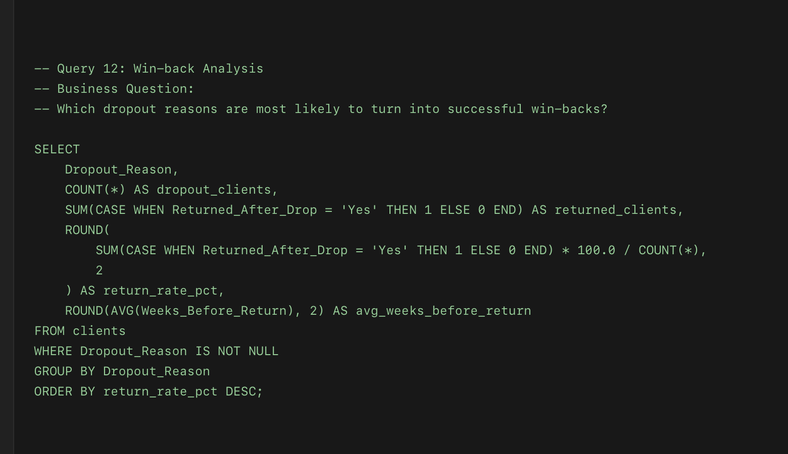
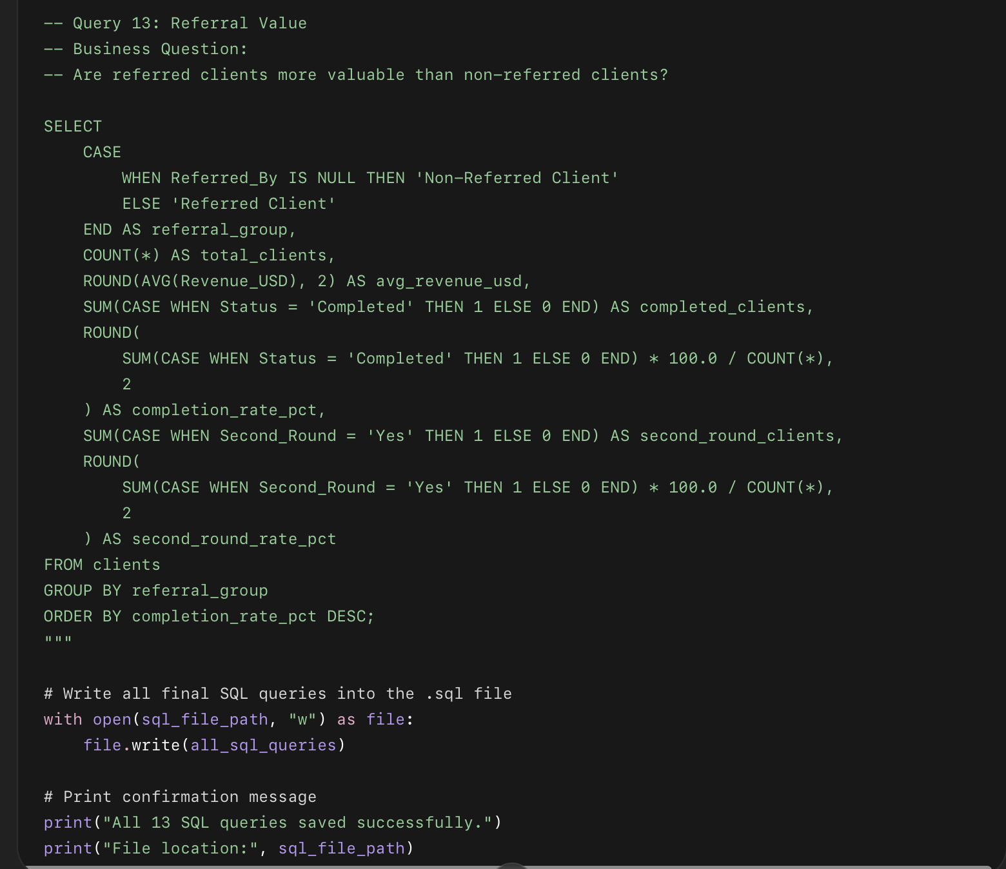

What this code did
- Created one large SQL text block containing all 13 finalized SQL queries.
- Included comments above each query explaining the business question.
- Used "w" mode to overwrite the old file and replace it with the clean final version.
- Saved everything inside: 05_sql_queries/phase_2_business_analysis_queries.sql
- This gives you one professional SQL file for your portfolio.

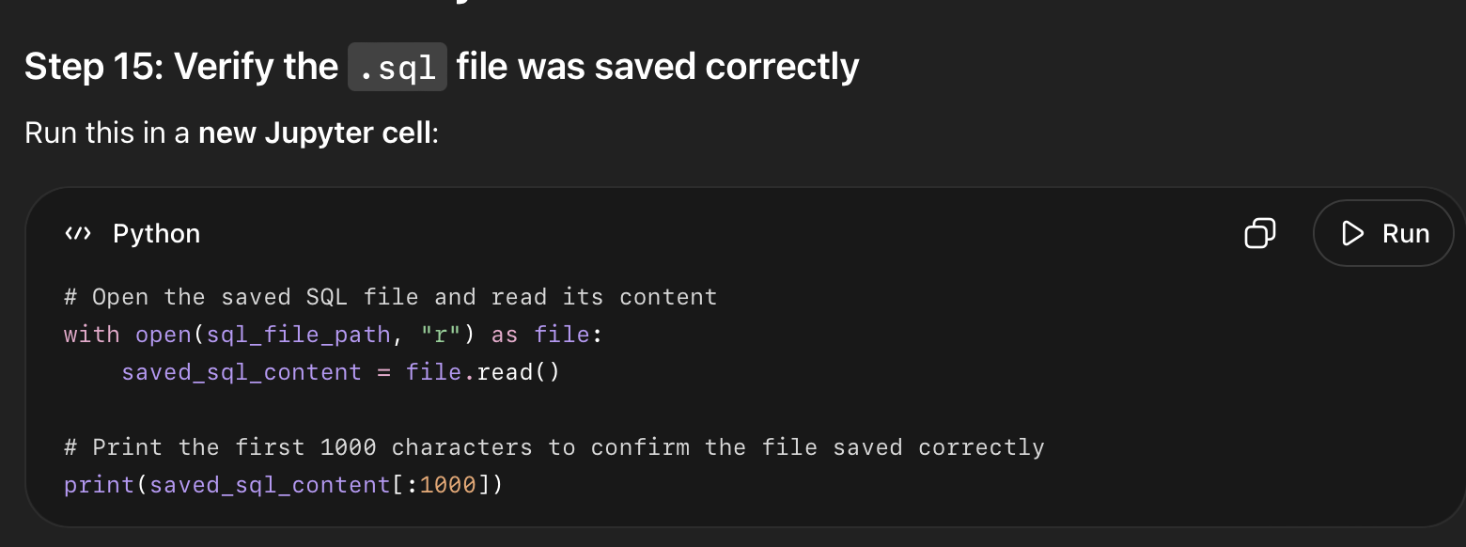

What this code did
- Opened your saved .sql file.
- Read the contents of the file.
- Printed the first part of the file so you can confirm the queries were actually saved.
- This is a quick quality check before we close Phase 2.

